**LOW LEVEL DESIGN**

**LOW LEVEL DESIGN**

**E-Comm Sales Dashboard**

|  |  |
| --- | --- |
| **Written By** | **Adil Anwar** |
| **Document Version** | **1.2** |
| **Last Revised Date** | **25-10-2022** |

**LOW LEVEL DESIGN**

**DOCUMENT CONTROL**

**Change Record:**

|  |  |  |  |  |  |  |  |  |  |  |  |  |
| --- | --- | --- | --- | --- | --- | --- | --- | --- | --- | --- | --- | --- |
|  | **VERSION** |  |  | **DATE** |  |  | **AUTHOR** |  |  | **COMMENTS** |  |  |
|  |  |  |  |  |  |  |  |  |
|  | 1.0 |  |  | 18 Oct 2022 |  |  | Adil Anwar |  |  | First Draft |  |  |
|  | 1.1 |  |  | 22 Oct 2022 |  |  | Adil Anwar |  |  | Second Draft |  |  |
|  | 1.2 |  |  | 25 Oct 2022 |  |  | Adil Anwar |  |  | Final Draft LLD |  |  |
|  |  |  |  |  |  |  |  |  |  |  |  |  |

**Reviews:**

|  |  |  |  |  |  |  |  |  |  |  |  |  |
| --- | --- | --- | --- | --- | --- | --- | --- | --- | --- | --- | --- | --- |
|  | **VERSION** |  |  | **DATE** |  |  | **REVIEWER** |  |  | **COMMENTS** |  |  |
|  |  |  |  |  |  |  |  |  |
|  |  |  |  |  |  |  |  |  |  |  |  |  |
|  |  |  |  |  |  |  |  |  |  |  |  |  |
|  |  |  |  |  |  |  |  |  |  |  |  |  |
|  |  |  |  |  |  |  |  |  |  |  |  |  |

**Approval Status:**

|  |  |  |  |  |  |  |  |  |  |  |  |  |  |  |  |
| --- | --- | --- | --- | --- | --- | --- | --- | --- | --- | --- | --- | --- | --- | --- | --- |
|  | **VERSION** |  |  | **REVIEW** |  |  | **REVIEWED BY** |  |  | **APPROVED** |  |  | **COMMENTS** |  |  |
|  |  |  |  |  |  |  |  |  |  |  |
|  |  |  |  | **DATE** |  |  |  |  |  | **BY** |  |  |  |  |  |
|  |  |  |  |  |  |  |  |  |  |  |  |  |  |  |  |
|  |  |  |  |  |  |  |  |  |  |  |  |  |  |  |  |
|  |  |  |  |  |  |  |  |  |  |  |  |  |  |  |  |
|  |  |  |  |  |  |  |  |  |  |  |  |  |  |  |  |

**LOW LEVEL DESIGN**

**Contents:**

**1. Introduction** **04**

**1.1 What is Low-Level Design Document?** **04**

**1.2 Scope** **04**

**2. Architecture** **05**

**3. Architecture Description** **08**

**3.1 Data Description** **08**

**3.2 Web Scrapping** **08**

**3.3 Data Transformation** **08**

**3.4 Data insertion into database** **08**

**3.5 Connection with SQL server** **08**

**3.5 Export Data from database** **12**

**3.6 Deployment** **12**

**4. Unit test cases** **15**

**LOW LEVEL DESIGN**

**1. Introduction**

**1.1 What is Low-Level design document?**

The goal of the LDD or Low-level design document (LLDD) is to give the internal logic design of the actual program code for the Sales dashboard. LDD describes the class diagrams with the methods and relations between classes and programs specs. It describes the modules so that the programmer can directly code the program from the document.

**1.2 Scope**

Low-level design (LLD) is a component-level design process that follows a step-by-step refinement process. The process can be used for designing data structures, required software architecture, source code and ultimately, performance algorithms. Overall, the data organization may be defined during requirement analysis and then refined during data design work.

**ARCHITECTURE :**

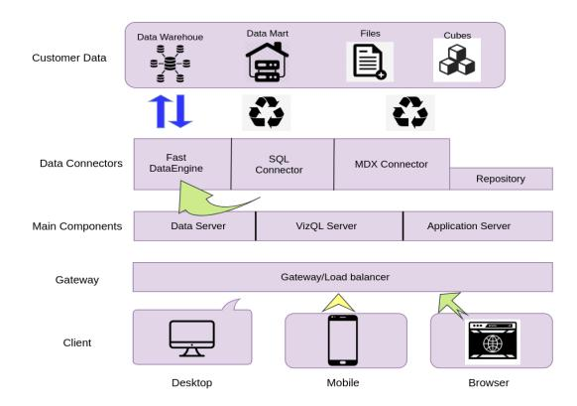

**Tableau Server Architecture**

Tableau has a highly scalable, n-tier client-server architecture that serves mobile clients, web clients and desktop-installed software. Tableau Server architecture supports fast and flexible deployments.

The following diagram shows Tableau Server’s architecture:

**LOW LEVEL DESIGN**

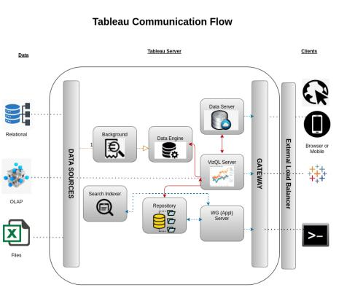

Tableau Server is internally managed by the multiple server processes:

**1. Gateway/Load Balancer**

It acts as an Entry gate to the Tableu Server and also balances the load to the Server if multiple Processes are configured.

**2) Application Server:-**

Application Server processes (wgserver.exe) handle browsing and permissions for the Tableau Server web and mobile interfaces. When a user opens a view in a client device, that user starts a session on Tableau Server. This means that an Application Server thread starts and checks the permissions for that user and that view.

**3) Repository:-**

Tableau Server Repository is a PostgreSQL database that stores server data. This data includes information about Tableau Server users, groups and group assignments, permissions, projects, data sources, and extract metadata and refresh information.

**4) VIZQL Server:-**

Once a view is opened, the client sends a request to the VizQL process (vizqlserver.exe). The VizQL process then sends queries directly to the data source, returning a result set that is rendered as images and presented to the user. Each VizQL Server has its own cache that can be shared across multiple users

**5) Data Engine:-**

It Stores data extracts and answers queries.

**LOW LEVEL DESIGN**

**6) Backgrounder:-**

The backgrounder Executes server tasks which includes refreshes scheduled extracts, tasks initiated from tabcmd and manages other background tasks.

**7) Data Server:-**

Data Server Manages connections to Tableau Server data sources

It also maintains metadata from Tableau Desktop, such as calculations, definitions, and groups.

1. **Architecture Description**
2. **Data Description CustKey : Customer Unique ID DateKey: Date**

**Discount Amount: Discount given on the products**

**Invoice Date: Date of invoice issuance**

**Invoice Number: Unique invoice number generated for each order**

**Item Class: Class of the item purchased**

**Item Number: Item identification number given to each item class**

**Item: Name of the item**

**Line Number: NA**

**List Price: List Price of the item**

**Order Number: Order Number assigned to each order made**

**Promised Delivery Date : Estimated delivery date for each order**

**Sales Amount: Amount at which the item was sold**

**Sales Amount Based on List Price: Amount based on the List Price of the product**

**Sales Cost Amount: Cost Price of the product**

**Sales Margin Amount: Margin acquired from each of the product**

**Sales Price: Sales Price of the item**

**Sales Quantity: Quantity available in the inventory**

**Sales Rep: Sales representative Id**

**U/M: Selling Area name**

**3.2. Web Scrapping**

Web scraping is a technique to automatically extract content and data from websites using bots.

**LOW LEVEL DESIGN**

It is also known as web data extraction or web harvesting. Web scrapping is made simple now days, many tools are used for web scrapping. Some of python libraries used for web scrapping are Beautiful Soup, Scrapy, Selenium, etc.

**3.3. Data Transformation**

In the Transformation Process, we will convert our original datasets with other necessary attributes format. And will merge it with the Scrapped dataset.

**3.4. Data Insertion into Database**

1. Database Creation and connection - Create a database with name passed. If the database is already created, open the connection to the database.
2. Table creation in the database.
3. Insertion of files in the table

**3.5 Make the SQL connection and set up the data source**

**Step 1: Configuring Tableau**

Launch Tableau on your workstation and select SQL Server from the connect column on the left. This will open a dialogue box where you need to provide the connection details for SQL Server. To connect with tableau, you will need to provide information about the server which hosts your database. If you want to connect to a contained database, you can also specify the name of the database.

To connect with a port other than the default port, you need to specify the port and server as follows:



Example query: my_server 8051

There are two ways in which you can sign-in to the server, either by using Windows authentication or by using the username and password. Using the username and password becomes a must if you’re working with a password-protected server in a non-Kerberos environment.

**LOW LEVEL DESIGN**

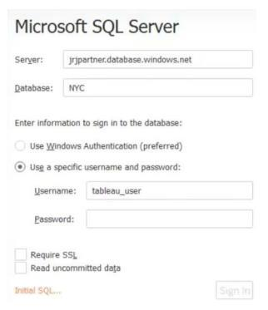

Click on Sign in to establish a connection. This will enable a connection without SSL. To establish an SSL enabled connection, click the Require SSL checkbox before you sign in. SQL Server provides an option to let the user queries access the modified rows even before they have been committed. This option is called Read Uncommitted data. It saves time by preventing complex queries such as extract refreshes from locking the database and causing a delay. If this option is unchecked, Tableau makes use of default isolation levels.

If you want to run a specific SQL command every-time a new connection is established, you can use the Initial SQL option. This will open a dialogue box, where you can specify your desired SQL query.

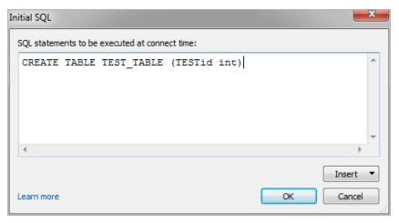

**Step 2: Configuring Data Source**

The data source page loads up after configuring the Tableau connector and successfully signing in.

This is how the page looks like:

**LOW LEVEL DESIGN**

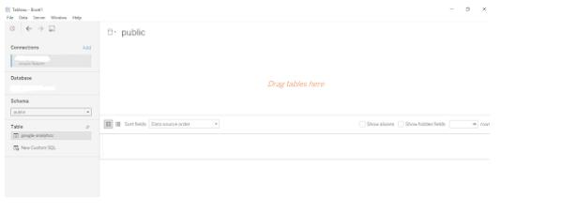

Select the data source name option and give a unique name to the database you are using. It’s considered a good practice to have a unique name as it makes it much easier for users to identify the database from which data is being fetched. To select the desired schema, you can use the schema drop-down list from the column on the left. You can also perform a text-based search to find the desired option. Now similarly find and select the desired table and drag it onto the canvas.

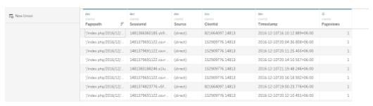

This is how you can connect SQL Server with Tableau. Now click on the sheets tab to begin the analysis. Custom SQL features can be used to focus on specific SQL statements, rather than querying the entire database. Click on the Custom SQL option from the panel on the left. A new dialogue box will now open up, where you can provide the query you want to execute.

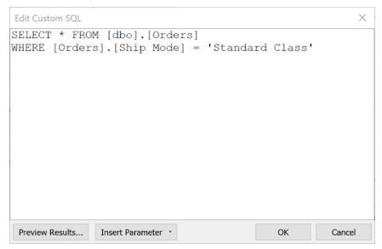

**LOW LEVEL DESIGN**

**3.5. Export Data from Database**

Data Export from Database - The data in a stored database is exported as a CSV file to be used for Data Pre-processing.

**3.6 Deployment**

Once you’ve completed your dashboard, follow these steps:- Server, Tableau Public, Save to Tableau Public . You may be prompted to log into your Tableau Public profile first if this is your first time publishing.

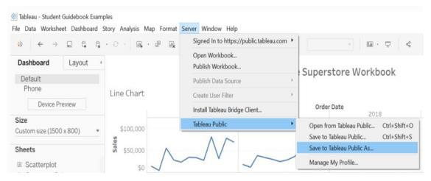

Next, fill out the title you want your viz to have and click “save”.

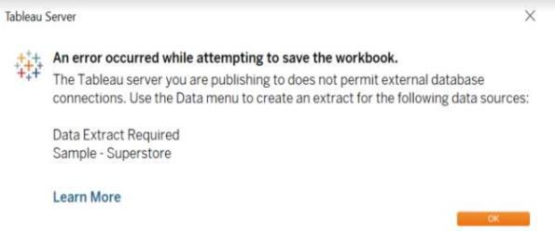

This message means that your connection to the Sample-Superstore data set is a live connection. Tableau Public cannot host live connections, so you’ll need to convert your connection to an extract (like a frozen screenshot of your data).

Here in the below screenshot, we can see that out workbook has been published to tableau public.

**LOW LEVEL DESIGN**

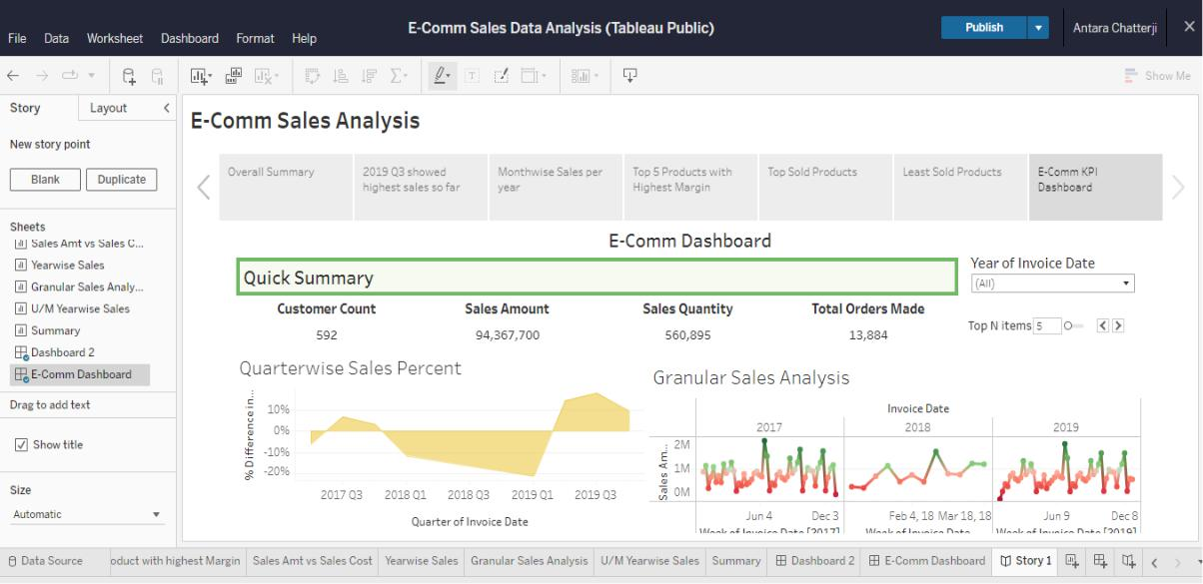

**4. Unit Test Cases**

|  |  |
| --- | --- |
| **TEST CASE DESCRIPTION** | **EXPECTED RESULTS** |
| Year of Invoice Dropdown | When clicked a dropdown should occur |
|  | which has all the years listed |
| Top N Items | The parameter should return the specified |
|  | number of items |
| Granular Sales Analysis | This is one of the most important graph to |
|  | perform the LOD analysis of the Sales data |
| Quarter Graph | The area under the graph shows the sales |
|  | for that Quarter |
| Sales Amount vs Sales Quantity | An analysis of Quantities sold and the sales |
|  | earned |
| Products with Highest Margins | Parameter lists the product names with |
|  | highest margins |
| Top Sold Products | Parameter lists all the products that are top |
|  | selling overall (and/or) yearwise |
| Least selling products | Parameter lists all the products that are |
|  | least selling overall (and/or) yearwise |
| E-comm Dashboard | Contains required KPIs to understand Sales |
|  | distribution throughout 3 years |

Tableau Public Link:

https://public.tableau.com/app/profile/adil.anwar/viz/SalesDashboard_16668786953450/Dashboard1